World History Unit 1 Study Guide

1. What was the Fertile Crescent?
2. What is a ziggurat?
3. What was important about pharaohs? What was their relation to Pyramids?
4. What do we call Egyptian form of writing?

1. Why is the development of writing important?
2. What is polytheism?
3. What is a dynasty?
4. What was Hammurabi famous for?
5. How did Hammurabi’s achievement from question 8 affect different social classes, men, and women?
6. What are the similarities between Egyptian and Mesopotamian society?

1. Why was it easier to farm in Egypt versus Mesopotamia?
2. Who were the Phoenicians?
3. What was one of the major contributions of the Phoenicians?
4. What is a Theocracy?

**THE RIVER VALLEY CIVILIZATIONS**

**I. THE NEOLITHIC REVOLUTION LEADS TO THE RIVER VALLEY CIVILIZATIONS**

**A**.**NEOLITHIC REVOLUTION:** The discovery of _______________during the Neolithic Revolution allowed nomadic people to settle into villages and towns; these eventually became __________________

a. The world’s first civilizations all began in ________ _____________

b. The ________civilization began in an area known as _____________________; some of the other early civilizations were China, Ancient Egypt, and the Indus Valley

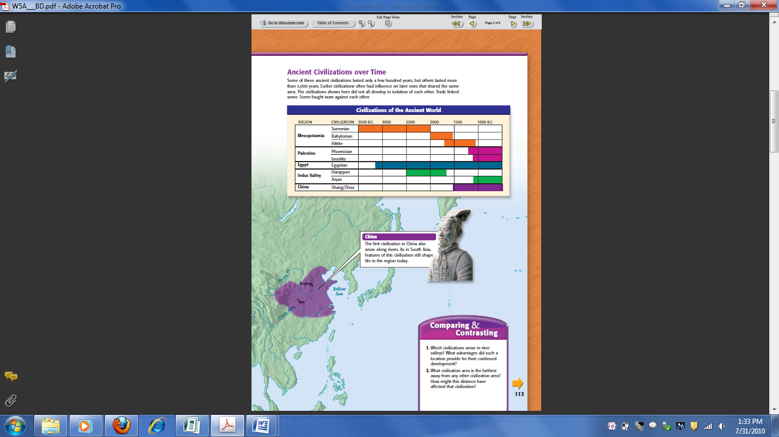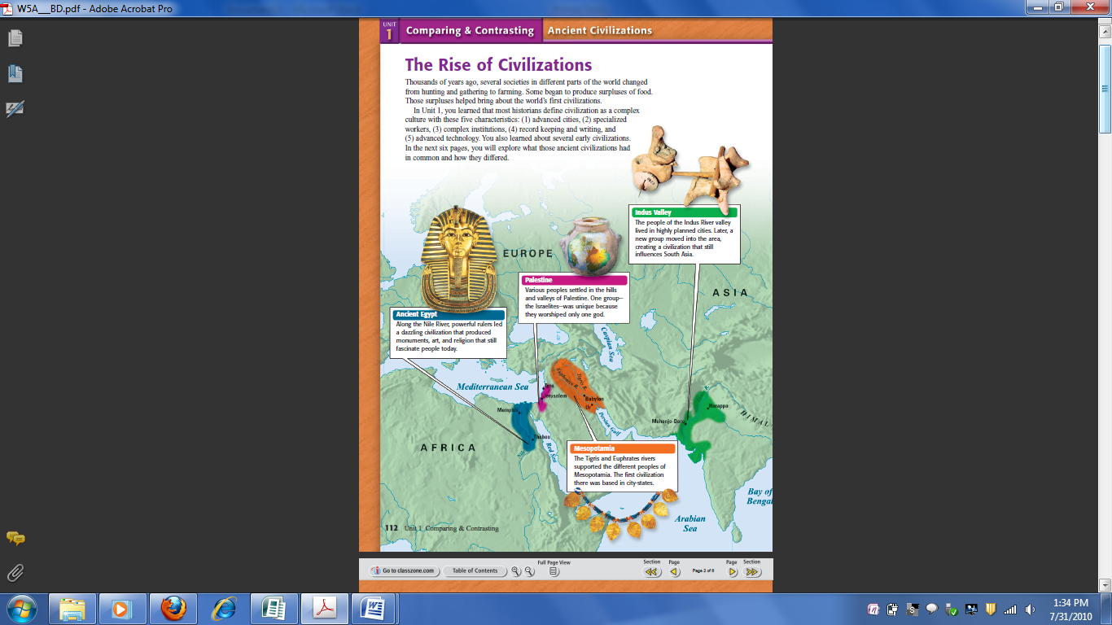

**B. MESOPOTAMIA**:

a. Mesopotamia means “_____ __________ _____ __________” and is often called the “Fertile Crescent” or referred to as the “Cradle of Civilization”

b. The ________ and ______________Rivers flooded once per year, leaving behind fertile soil ideal for farming (a perfect place to start a civilization)

c. The ________civilization that developed in the “Fertile Crescent” of Mesopotamia was the kingdom of ________

d. Surrounding deserts and the lack of natural barriers attracted ____________to Mesopotamia and   
made the Sumerians vulnerable to ___________; this led to other kingdoms rising in Mesopotamia

**LASTING CONTRIBUTIONS OF MESOPOTAMIA**

1. ADVANCED CITIES

a. Sumerian city-states were protected by ______ ________; at the city center was a temple called a ____________

2. SPECIALIZED WORKERS

a. At the top of society were ____________, and then ________

b. In the middle were skilled workers, like ________________

c. At the bottom, were common ______________and ___________

3. COMPLEX INSTITUTIONS (RELIGION)

a. Mesopotamia’s Sumerians and Babylonians were __________________(many gods)

b. The Hebrews in nearby Palestine were the first __________________ (single god) faith in history (Judaism)

c. The holy book of Judaism is the Torah; God gave Moses the 10 Commandments which serve as ________ ______

4. COMPLEX INSTITUTIONS (GOVERNMENT)

a. Babylonian King Hammurabi created the first ________ _________

b. Hammurabi’s Code had 282 laws based on ____________and ______________(for example: “an eye for an eye”)

c. The code had ____________ _______________ for the various levels of society

5. WRITING

a. Sumerians made the world’s first writing called ________________

b. Phoenicians simplified cuneiform to a 22 letter _____________

c.Phoenician merchants spread the alphabet throughout the _________________world; the alphabet influenced Greek, Latin, and ____________

6. TECHNOLOGY

a. Sumerian ________________ include the ____________, sail, plow, and bronze metalwork

**C. ANCIENT EGYPT**:

a. Egypt’s civilization began along the _______ ____________in North Africa

b. Egypt was bordered on both sides by miles of scorching ____________;these natural barriers isolated Egypt and _________________ it from outside invasion

c. The Nile River’s annual floods were predictable and provided ____________ ________for farming (a perfect place to start a civilization)

d. The Nile flooded so ________________that the Egyptians designed their calendar around it

e. Egypt has been called the “______ ____ ____ _______”there would be no Egyptian civilization without the Nile

**LASTING CONTRIBUTIONS OF ANCIENT EGYPT**

1. ADVANCED CITIES

a. Cities developed along the ______ ____________ in “Upper Egypt” and “Lower Egypt”

2. SPECIALIZED WORKERS

a. Ancient Egypt had a ____________of specialized workers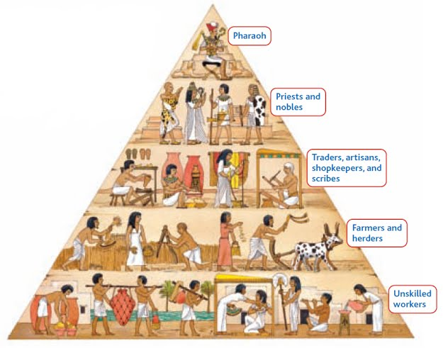

3. COMPLEX INSTITUTIONS (GOVERNMENT)

a. Pharaohs ruled Egypt as “_______-______” and were thought to control nature

b. Egyptians constructed _______________ and elaborate tombs for the pharaohs

4. COMPLEX INSTITUTIONS (RELIGION)

a. Egyptians were polytheistic and believed the gods ________________ all aspects of life

5. WRITING

a. Egyptian ___________________were both pictograms and a phonetic alphabet

b. Hieroglyphics were translated using the __________ __________

c. This stone was inscribed with a ___________from a pharaoh; it has three languages on it, so it provided the basis for _________________Egyptian hieroglyphics

6. TECHNOLOGY

a. Egyptian ideas included a 365-day ______________, geometry, astronomy, and the _____________