**Geography**

**Russian Geography:** Russia is a large country that has many different geographic regions. In the south there are hilly grasslands. In the north, there are dense forests. There were also two large **steppes** in the eastern and western region. A steppe is a large area of flat unforested grassland. The steppes were home to nomadic people. There is very little rain and the dry plain supports hardy grasses but is difficult to grow crops. There are also dramatic changes in temperatures and there is a milder climate and more rainfall in east than the west.

**Pastoralists:** One way different groups in Russia survived was by being pastoralists. **Pastoralists** herded domesticated animals and were constantly on the search for pastures to feed their herds. These nomads traveled together in clans, and each clan member was descended from common ancestors. There was also constant interaction between clans, often engaged in peaceful trade. One group of pastoralists that rose to power was the Mongols. The Mongols roamed the eastern steppe for centuries and were made up of loosely organized clans. However, they united under the common purpose of conquest.



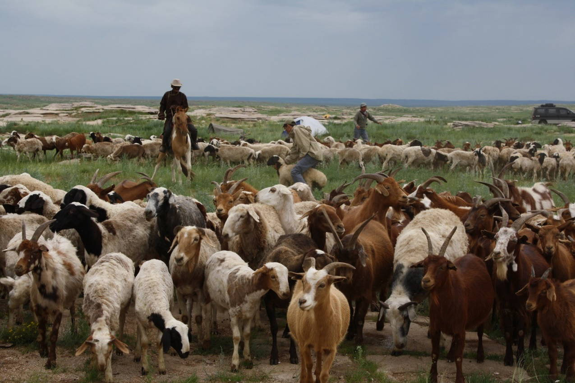

**Power**

The Mongol Empire was the largest continuous land empire ever created. It stretched from parts of Eastern Europe to China in Asia. The Mongol army organized in the Russian steppes and under strong leadership drove south, east, and west out of inner Asia. In Asia they completed their conquest of northern China and invaded Korea. They took over the major cities throughout Russia. The Mongols also started making their way toward Western European cities. However, in the 1250s the Mongols halted their westward campaign and turned their attention to the Middle East in Asia.

Many of the areas invaded by the Mongols never recovered. The populations of some cities were wiped out as destruction followed where the Mongols went. For example, the Mongols destroyed ancient irrigation systems in areas such as the Tigris and Euphrates valleys. Thus, after the Mongols took over, the land could no longer support resettlement of new people. While ferocious in war, the Mongols were quite tolerant in peace. They rarely imposed their beliefs or way of life on those they conquered. Over time, some Mongol rulers even adopted aspects of the culture of the people they ruled.

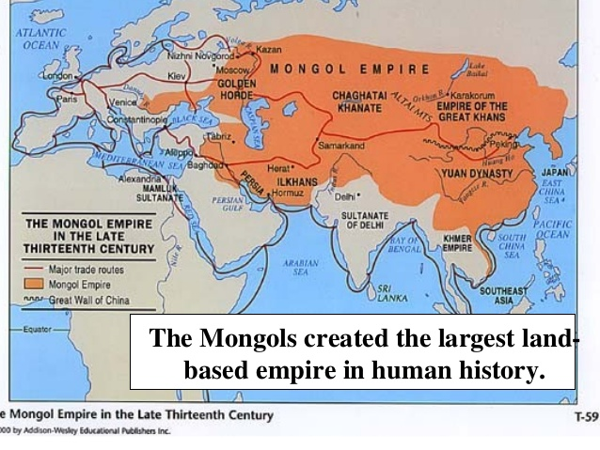

**Nomads**

The Mongols lived in a *steppe*, or vast expanse of dry grassland, across Asia. Nomadic peoples were pastoralists—that is, they herded domesticated animals. They were constantly on the move, searching for good pasture to feed their herds. But they did not wander. Instead, they followed patterns based on the seasons and regularly returned to the same campsites. However, this constant movement often caused conflict among nomadic groups over grassland and water rights.

Asian nomads practically lived on horseback as they followed their huge herds over the steppe. They depended on their animals for food, clothing, and housing. Their diet consisted of meat and milk. They wore clothing made of skins and wool, and they lived in portable tents called **yurts**.

The differing ways of life of nomadic and settled peoples resulted in constant interaction between them. Often, they engaged in peaceful trade. Nomads were accustomed to scarcity and hardship. They prided themselves on their toughness. However, they were sometimes tempted by the rich land and relative wealth of townspeople and took what they wanted by force. As a result, settled peoples lived in constant fear of raids of the nomads.



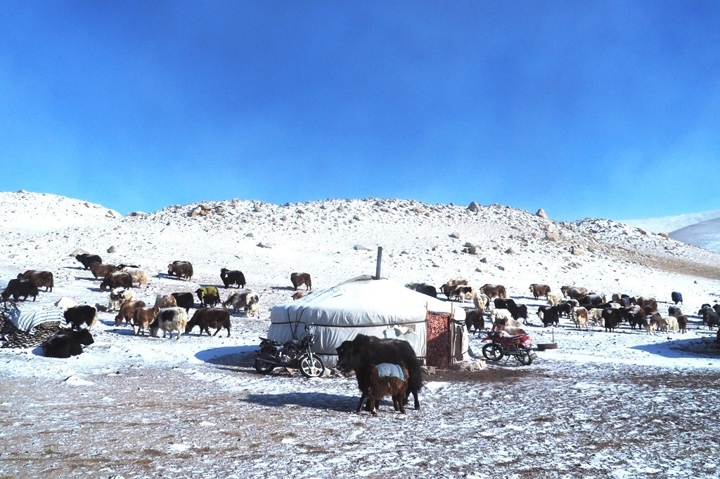

**Leader: Genghis Khan**

Around 1200, a Mongol clan leader named **Temujin** sought to unify the Mongols under his leadership. When he became undisputed leader of all Mongol tribes after a series of battles, he took the name “**Genghis Khan**”, which means “universal ruler”. He fought and defeated his rivals one by one. Over the next 21 years, Genghis led the Mongols in conquering much of Asia. Genghis launched a campaign of terror across Central Asia. The Mongols destroyed one city after another and slaughtered many people. By 1225, Central Asia was under Mongol control.

Several characteristics lay behind Genghis Khan’s stunning success as a conqueror. First, he was a brilliant organizer. He assembled his Mongol warriors into a mighty fighting force. Following the model of the Chinese military, Genghis grouped his warriors in armies of 10,000. These in turn were organized into 1,000-man brigades, 100-man companies, and 10-man squads. He put his most battle-proven and loyal men in command of these units.

Genghis Khan used cruelty as a weapon. He believed in terrifying his enemies into surrender. If a city refused to open its gates to him, he might kill the entire population when he finally captured the place. The terror the Mongols inspired spread ahead of their armies, which led many towns to surrender without a fight. This was known as psychological warfare.

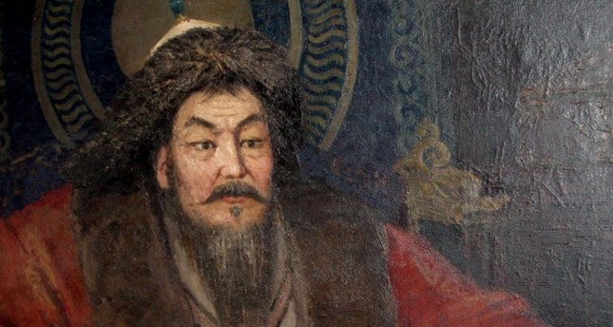

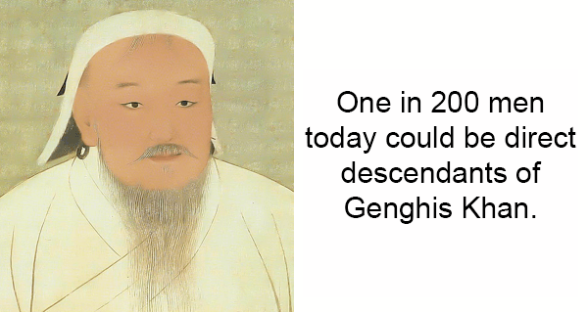

**Warriors**

Mongol soldiers were amazing horsemen, having spent all their lives in the saddle. Young men played games and gave them the chance to practice skills they would use in battle and gave their leaders the opportunity to spot promising warriors.

When on the move, each soldier was accompanied by three extra horses. By changing mounts, soldiers could stay in the saddle for up to ten days and nights at a time. When charging toward a target, they covered as much as 120 miles a day. If food was scarce, a Mongol soldier might make a small gash in the neck of one of his horses and sustain himself by drinking the blood.

A key to Mongol horsemanship was the stirrup, which was invented on the steppe in the second century B.C. Stirrups enabled a mounted warrior to stand, turn, and shoot arrows behind him.

Mongol warriors used a **compound bow**, an extremely flexible and durable bow that was considered the super-weapon of its time. It could shoot arrows faster and more accurately than any bow before it. If fired properly, it could pierce armor at 190 MPH. Groups of Mongol archers could rain arrows on the enemy from 300 yards away.

Their speed on horseback, weapons, and fighting skill made the Mongols an unstoppable enemy.

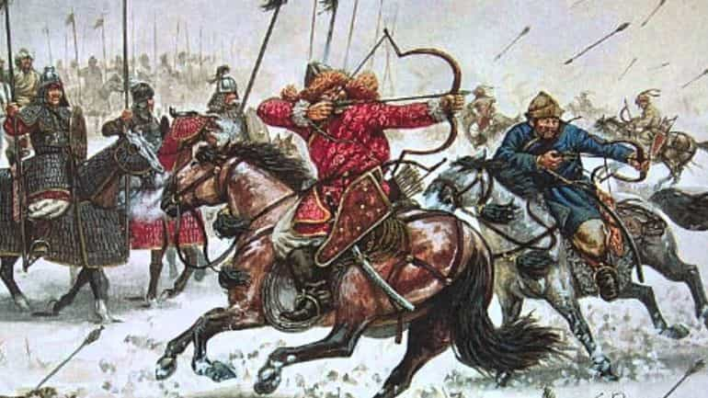

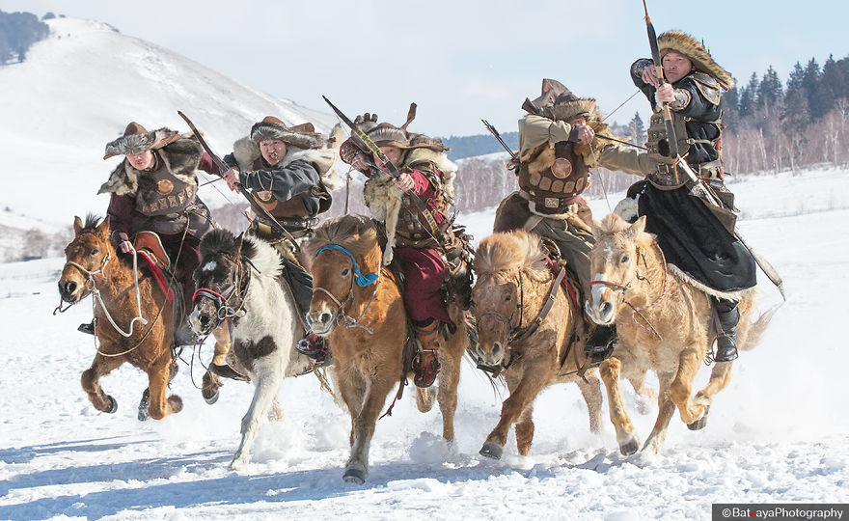

**Military Techniques**

**Encirclement and opening**: The main reason for these maneuvers was to encircle the city to cut off escape and overwhelm from both sides. If the situation deteriorated on one of the fronts or flanks, the leader from the hill directed one part of the army to support the other. If it appeared that there was going to be significant loss, the Mongols would retreat to save their troops and would engage the next day, or the next month, after having studied the enemies' tactics and defenses in the first battle, or again send a demand to surrender after inflicting some form of damage.

**Feigned retreat:** The Mongols very commonly practiced the **feigned** [*faking*] **retreat**, perhaps the most difficult battlefield tactic to execute. This is because a feigned retreat amongst untrained troops can often turn into a real retreat if an enemy presses into it. Pretending disarray and defeat in the heat of the battle, the Mongols would suddenly appear panicked and turn and run, only to pivot [*turn around*] when the enemy was drawn out, destroying them. As this tactic became better known to the enemy, the Mongols would extend their feigned retreats for days or weeks, to falsely convince the chasers that they were defeated, only to charge back once the enemy again had its guard down or withdrew to join its main formation.

